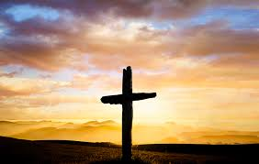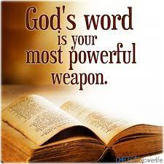­

**To learn more go to our website:**

**ibcpalmer.org**

**“Study to shew thyself approved unto God, a workman that needeth not to be ashamed, rightly dividing the word of truth.”**

**2 Timothy 2:15**

“**Thy word have I hid in mine heart, that I might not sin against thee”**

**Psalm 119:11**

**What is Bible quizzing?**

Bible quizzing is studying and recalling an assigned passage of scripture to answer questions in a Bible quizzing tournament.

**Who can Bible quiz?**

Bible quizzing is open to anyone from ages 12 to 22, who has an interest in studying God’s Word and fellowshipping with other fellow quizzers.

**When does Bible quizzing take place?**

Bible quizzing takes place once a year, either in the month of April or May. Which month depends on the council’s decision; however, studying starts many months before the actual event. The latest we recommend starting is in January.

**Where is the Alaska KJV Bible Quizzing Tournament held?**

The location will be chosen by the council each year and announced prior to the annual event.

**Alaska KJV Bible Quizzing Tournament**

CONTACT US

If you have any questions about Bible quizzing, please contact the council at Finn Rye’s number (907)- 355-0379.

If you would like us to come present the ministry, please contact the outreach group at Cecil McDaniel’s number (907)- 290-0446.

OUR MISSION

To encourage both the youth to hide God’s Word in their hearts and the churches to fellowship in this event.

[Grab your reader’s attention with a great quote from the document or use this space to emphasize a key point. To place this text box anywhere on the page, just drag it.]

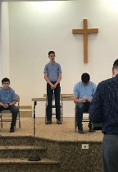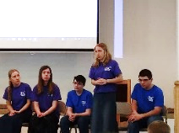oti

**Our Story**

This tournament was started by a group of individuals with a passion to encourage Bible memorization. The group knew that in order to start a ministry, a lot of hard work and dedication was going to be needed. Most importantly, though, we knew God must lead the ministry in order for it to be a success. We believe that this is the Lord’s will; therefore, we are ready to put in the hard work needed for this ministry to be a success.

The Alaska KJV Bible Quizzing Tournament has its own council, Articles of Faith, and Bible version standard. The council is in charge of planning, organizing, and coordinating the entire event. The Articles of Faith are the fundamentals that all participating churches must agree to in order to partake in Bible quizzing. You can request a copy by contacting us or downloading it online. The KJV is the official tournament Bible version. We encourage all teams to use this version as their main study source, but it is not required.  On the day of the event, all the quiz questions will come from the King James Version of the Bible.

We know that quizzing is completely new for some of you.  We hope this brochure can answer most of your questions, but we don’t expect it to answer all of them. If you have any questions about quizzing or you would like us to come visit your church, please don’t hesitate to contact us. We hope to see you at the next Alaska KJV Bible Quizzing Tournament!

*“Whether therefore ye eat, or drink, or whatsoever ye do, do all to the glory of God.”*

1 Corinthians 10:31

**How to start a team?**

A team can have an innumerable number of quizzers, but only five can quiz at a time. A team must have a minimum of three quizzers and a youth leader in order to participate as a team. The youth leader is responsible for guiding and coaching the team. Each new team must have a supporting church that agrees with the Alaska KJV Bible Quizzing Tournament’s Articles of Faith. Once a church decides to take part in the competition and has a team, then they should contact the council to sign-up.

**Are there any fees?**

There are no entrance fees for quizzing. This event is for the whole family and is entirely ran off a love offering basis. The Alaska KJV Bible Quizzing Tournament doesn’t have any funds of its own or a bank account. Everything needed for the event is either donated or paid for voluntarily. Each participating church is encouraged to support, but is not required. A church can support, for example; by providing food for the fellowship meals before and after the event, or housing for traveling teams.

**Are there any other ministry opportunities?**

Yes, there are many opportunities for those who are not able to partake as a quizzer or a youth leader. Some opportunities could include; helping in the kitchen, running quiz lights, keeping score, or even watching kids. If you are interested in helping, please don’t be afraid to contact us as well.

**How can I benefit from quizzing?**

The greatest benefit that a young person will find in quizzing is the blessing of having the Word of the Lord committed to memory for a lifetime. The Holy Spirit speaks to us through His inspired scriptures, convicting our hearts and guiding our lives; therefore, knowing the scriptures allows God to communicate freely with his people.

**Why should I quiz?**

The main reason for anyone to quiz is to glorify God*, “that Christ might have the preeminence.”* Colossians 1:18*.* Also, some other reasons are; to increase in the knowledge of God, to fellowship with brothers and sisters in Christ, to encourage others in the Lord, to be a part of a ministry, and to have fun.

**How can I become a quizzer?**

First, we encourage each potential quizzer to pray and seek God’s will about quizzing. Once you and the Lord determine that it is God’s will, then you need to approach your pastor or youth leader for guidance and direction. Either you will need to find a current team to join, or start a new team at your church. Your pastor or youth leader will help in determining the best option.